**Data Visualization Associate Early Internship**

**Week – 2**

**Team – 12**

1. **Looker Studio Dashboard:**

**Looker Studio Report:**

Viewable Link: <https://lookerstudio.google.com/reporting/f5642989-5e19-4dae-9051-82b5f3a14634>

1. **Proof of connection:**

We have connected the data via supabase and via google sheet too.

* **Supabase connection proofs are below:**

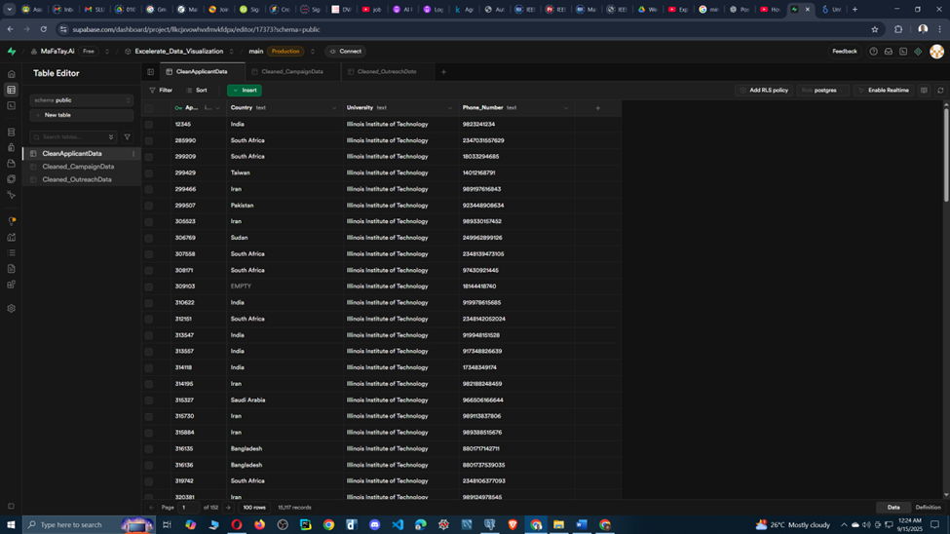

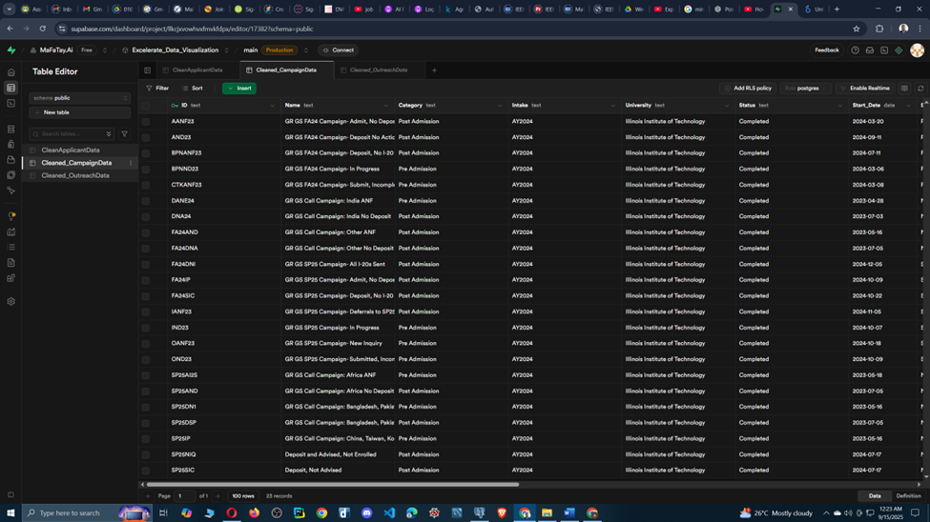

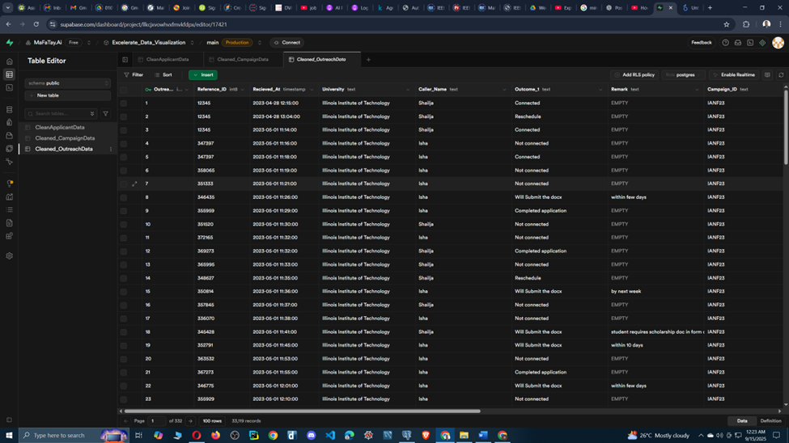

Queries in superbase

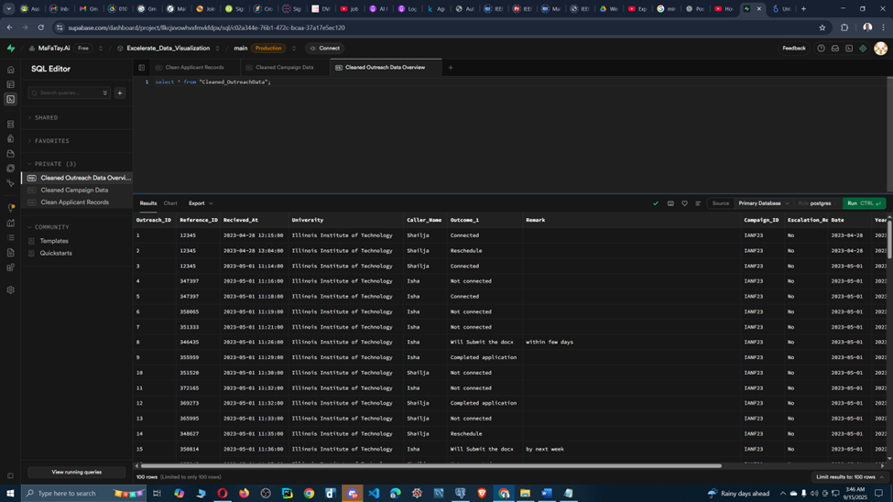

Connected data of Supabase with looker studio show below:

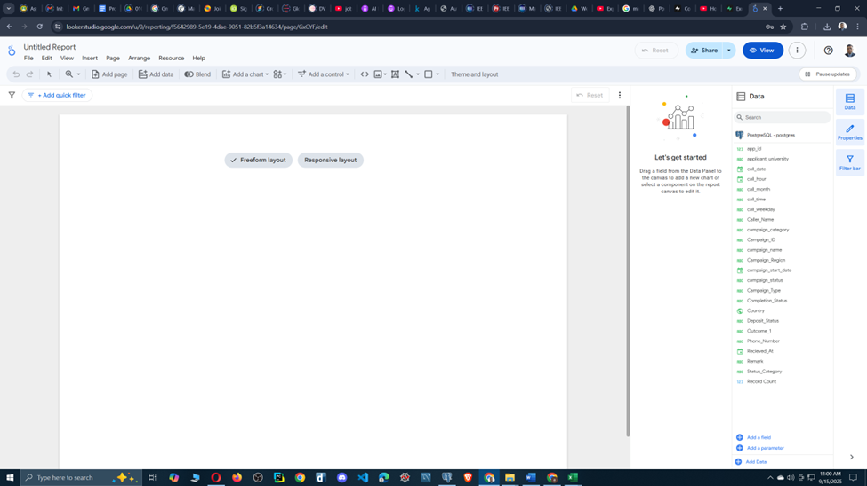

* CSV upload connection proofs are below:

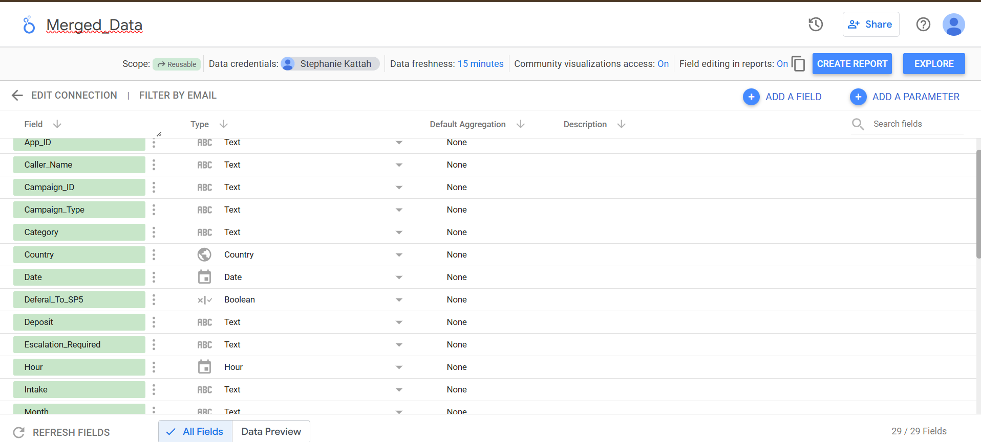

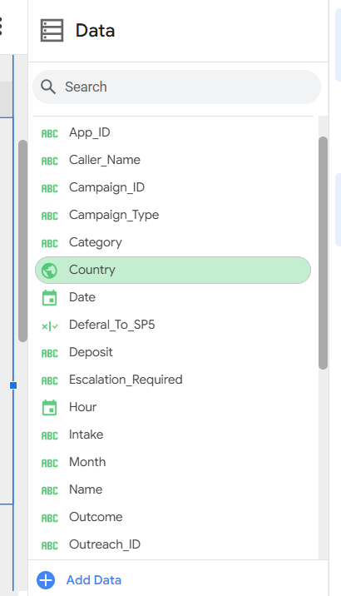

1. **Design Documentation:**

**The report follows this structure:**

Page 1: Shows general statistics on the calls and the different times at which were received.

Page 2: Dives into campaign distribution and agent performance.

Page 3: shows nationality distribution of the applicants

PAGE 1

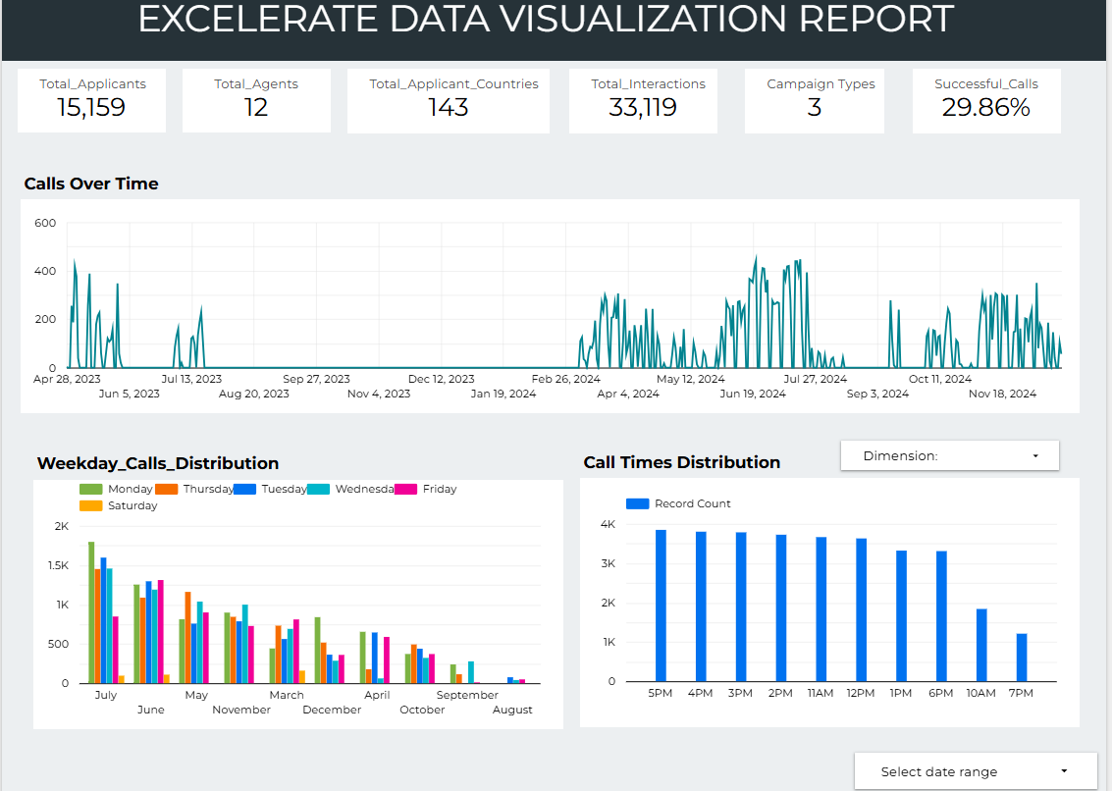

Firstly, created 6 scorecards which illustrate total number of applicants, total number of callers/agents, number of countries where applicants are from, total calls occurred between applicants and agents, total active campaigns, and lastly Successful conversations happened between Agents and applicants.

Throughout all pages of the Dashboard, the date range can be selected by the viewer.

Additionally, a time series chart called **Calls Over time**, shows the frequency of applicant calls across the selected time range. The most calls are received during June - July. Other peak seasons are in the months of May- June, March, October - December.

**Weekly_Calls_Distribution** shows the distribution of calls across the months and days of the week.

**Call_ Hour_Distribution** shows that most calls are received during 7pm and 5 pm.

Only 29.86% of the calls were connected. This reveals something that must be worked on.

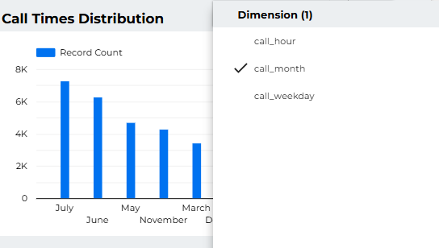

The dimensions of the bar chart can be changed to see the frequency of calls by: hour, month, weekday.

PAGE 2 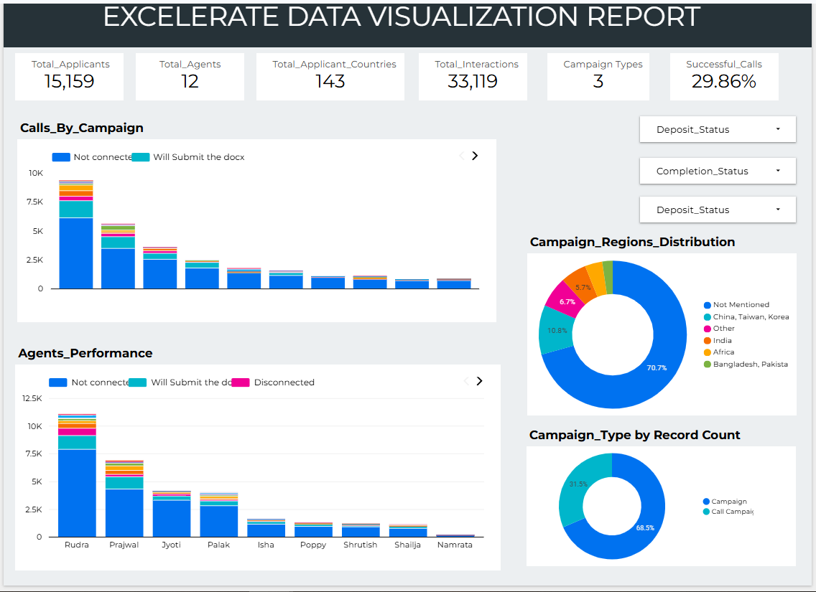

From the “**Agents_Performance**” chart we can see, Rudra has the most calls which did not connected and also had the most conversations with the applicants. After Rudra, it is Prajwal whose performance was good. There was a close competition in terms of performance between Jyoti and Palak.

After analysing both **Calls_By_Campaign** and **Agents_Performance** it is pretty prominent that most calls were not connected.

Both **Campaign_Regions_Distribution** and **Campaign Type by Record Count** exhibit a similar split of approximately 70% to 30%. This pattern arises because online Call Campaigns capture applicant location information, resulting in regions being recorded, whereas offline campaigns do not have region data since they were conducted in person without explicit regional tagging.

PAGE 3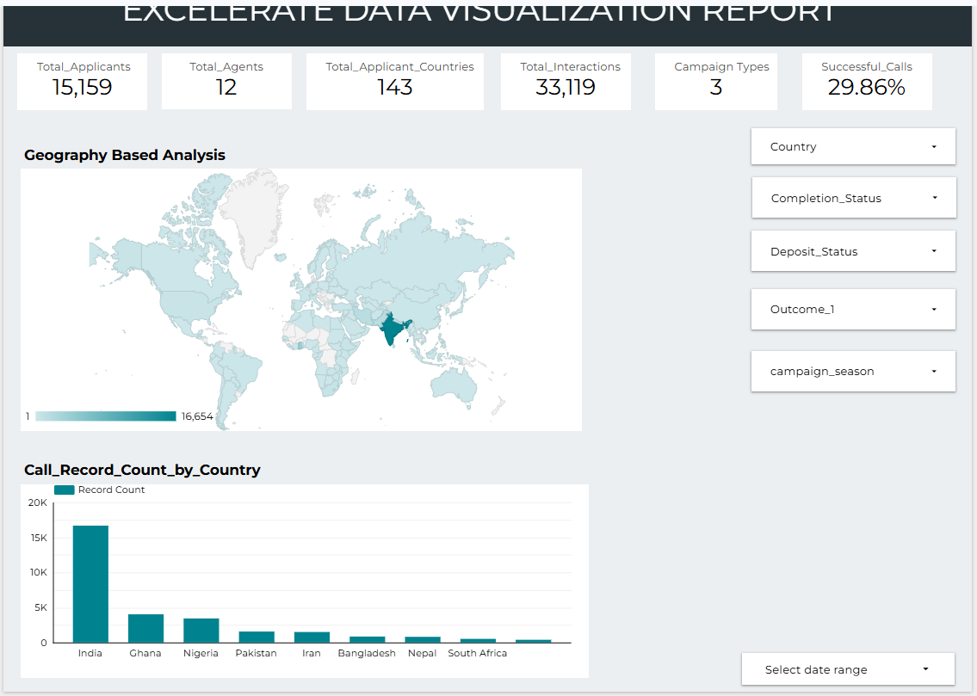

Geography Based (a geo chart) Analysis and Call_Record_Count_by_Country shows the distribution of applicants from the countries. Most of the applicants are from India, followed by Ghana and Nigeria.

Controls on the left of the graph allow users to customize the output based on Deposit_status, Outcome, Completion_status or Country Selection.